KUBERNETES TASK-05
- Create a namespace dev-environment and apply a resource-based quota that restricts the number of pods to 3 and services to 2.

Step 1: Create the Namespace
Run this command:
- kubectl create namespace dev-environment
Verify:
- kubectl get namespaces

✅ Step 2: Create ResourceQuota YAML
Create a file named resource-quota.yaml:
- nano resource-quota.yaml
Add this content:
apiVersion: v1
kind: ResourceQuota
metadata:
name: dev-quota
namespace: dev-environment
spec:
hard:
pods: "3"
services: "2"
Save and exit (CTRL+O, ENTER, CTRL+X).

✅ Step 3: Apply the ResourceQuota
- kubectl apply -f resource-quota.yaml

✅ Step 4: Verify the Quota
- kubectl get resourcequota -n dev-environment
Detailed view:
- kubectl describe resourcequota dev-quota -n dev-environment

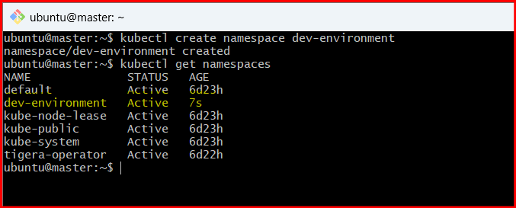
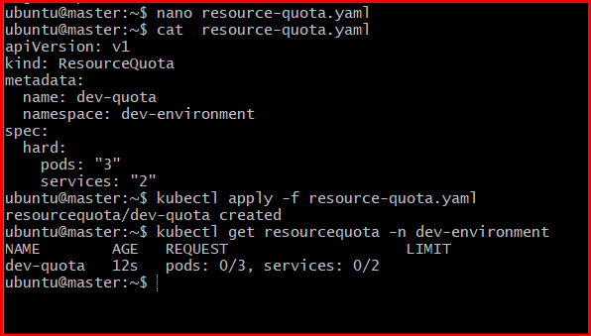
- Create a pod in the prod-environment namespace with 0.2 CPU and 200Mi memory requests, and 0.5 CPU and 500Mi memory limits.

Step 1: Ensure Namespace Exists
- kubectl create namespace prod-environment
(If it already exists, you’ll get a message and can ignore it.)

✅ Step 2: Create Pod YAML
- nano prod-pod.yaml
Add the following:
apiVersion: v1
kind: Pod
metadata:
name: prod-pod
namespace: prod-environment
spec:
containers:
- name: nginx-container
image: nginx
resources:
requests:
cpu: "200m" # 0.2 CPU
memory: "200Mi"
limits:
cpu: "500m" # 0.5 CPU
memory: "500Mi"
Save and exit.

✅ Step 3: Apply the YAML
- kubectl apply -f prod-pod.yaml

✅ Step 4: Verify Pod Creation
- kubectl get pods -n prod-environment

✅ Step 5: Verify Resource Requests & Limits
- kubectl describe pod prod-pod -n prod-environment
Look under Containers → Resources section. You should see:
- Requests: 200m CPU, 200Mi memory
- Limits: 500m CPU, 500Mi memory
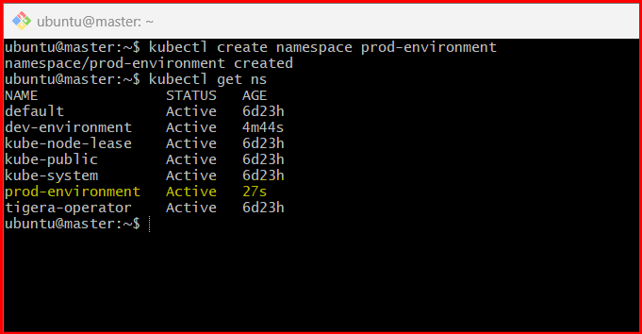

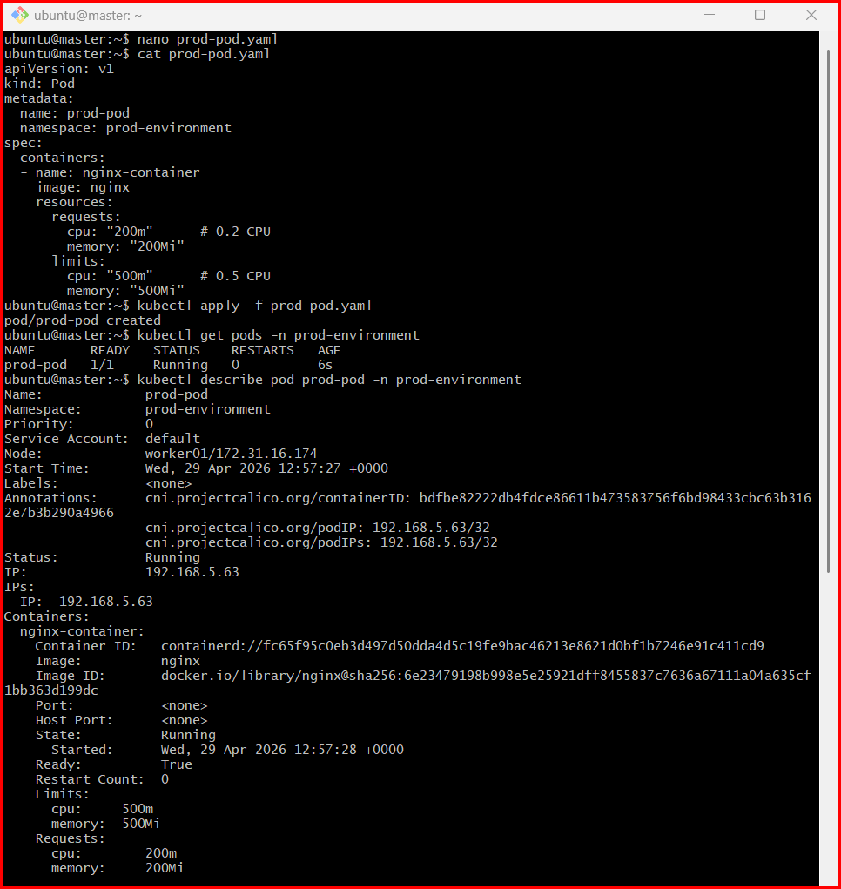

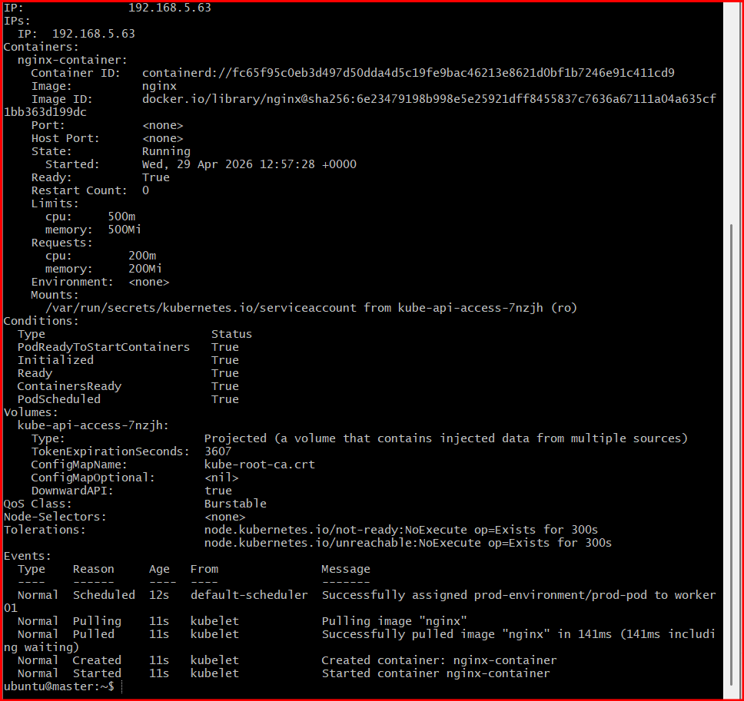

- In the staging-environment namespace, set a LimitRange that assigns default CPU and memory limits (300m CPU, 600Mi memory) and applies a minimum and maximum CPU.

Step 1: Create the Namespace (if not already)
- kubectl create namespace staging-environment

✅ Step 2: Create LimitRange YAML
- nano limitrange.yaml
Add the following configuration:
apiVersion: v1
kind: LimitRange
metadata:
name: staging-limitrange
namespace: staging-environment
spec:
limits:
- type: Container
default:
cpu: "300m"
memory: "600Mi"
defaultRequest:
cpu: "200m"
memory: "200Mi"
min:
cpu: "100m"
max:
cpu: "500m"

✅ Step 3: Apply the LimitRange
- kubectl apply -f limitrange.yaml

✅ Step 4: Verify
- kubectl get limitrange -n staging-environment
Detailed check:
- kubectl describe limitrange staging-limitrange -n staging-environment

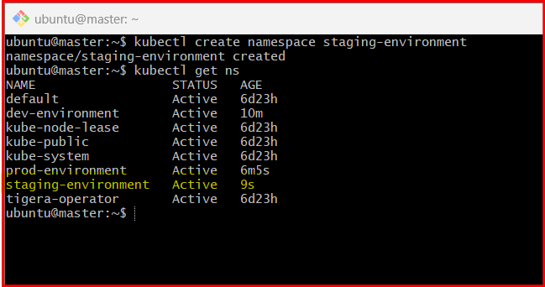

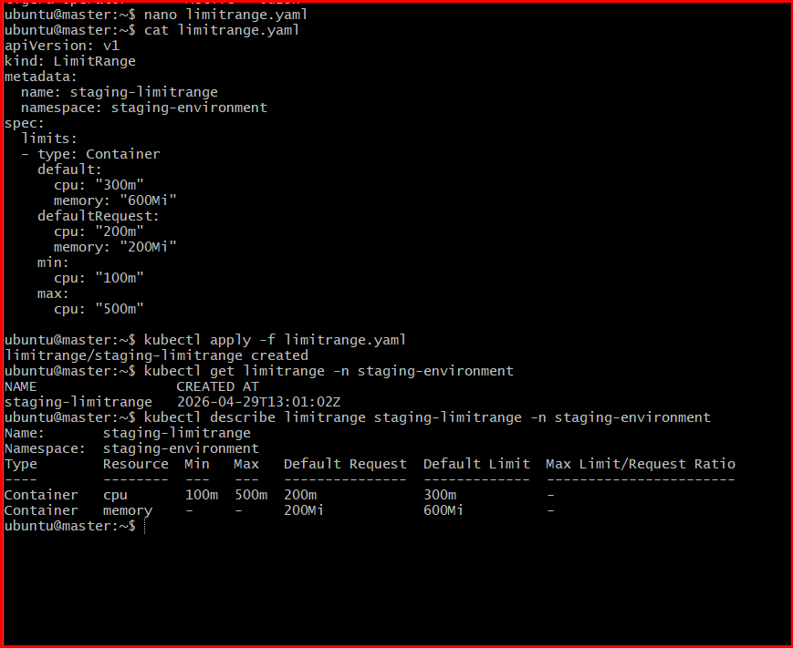

- Create a pod and a NodePort service in the default namespace, then create another pod in the test namespace and communicate between them using Service DNS.

Step 1: Create Pod in Default Namespace
- kubectl run nginx-pod --image=nginx --port=80
Verify:
kubectl get pods

✅ Step 2: Expose Pod as NodePort Service
kubectl expose pod nginx-pod \
--type=NodePort \
--port=80 \
--target-port=80 \
--name=nginx-service
Check service:
kubectl get svc

✅ Step 3: Create Test Namespace
kubectl create namespace test

✅ Step 4: Create Pod in Test Namespace
Use a pod with curl (for testing communication):
kubectl run test-pod \
--image=busybox \
-n test \
--restart=Never \
-- sleep 3600

✅ Step 5: Get Service DNS Name
Kubernetes DNS format:
<service-name>.<namespace>.svc.cluster.local
So your service DNS will be:
nginx-service.default.svc.cluster.local

✅ Step 6: Test Communication from Test Namespace Pod
Access the test pod:
kubectl exec -it test-pod -n test -- sh
Now inside the pod, run:
wget -qO- nginx-service.default.svc.cluster.local
OR (if curl exists):
curl nginx-service.default.svc.cluster.local

- Apply a LimitRange with a max limit/request ratio of 2 for memory in the performance-environment namespace, and test by creating a pod with mismatched resource requests and limits.

Step 1: Create Namespace
kubectl create namespace performance-environment

✅ Step 2: Create LimitRange YAML
nano limitrange-ratio.yaml
Add:
apiVersion: v1
kind: LimitRange
metadata:
name: memory-ratio-limit
namespace: performance-environment
spec:
limits:
- type: Container
maxLimitRequestRatio:
memory: "2"
👉 This means:
- limit ≤ 2 × request (for memory)

✅ Step 3: Apply LimitRange
- kubectl apply -f limitrange-ratio.yaml
Verify:
- kubectl describe limitrange memory-ratio-limit -n performance-environment

✅ Step 4: Create a Pod that VIOLATES the Rule ❌
nano bad-pod.yaml
apiVersion: v1
kind: Pod
metadata:
name: bad-pod
namespace: performance-environment
spec:
containers:
- name: nginx
image: nginx
resources:
requests:
memory: "200Mi"
limits:
memory: "500Mi" # ❌ 500 / 200 = 2.5 (violates ratio > 2)
Apply:
- kubectl apply -f bad-pod.yaml

🚨 Expected Result
You will get an error like:
Error from server (Forbidden):
pods "bad-pod" is forbidden:
maximum memory limit to request ratio per Container is 2, but provided ratio is 2.5

✅ Step 5: Create a VALID Pod ✔
nano good-pod.yaml
apiVersion: v1
kind: Pod
metadata:
name: good-pod
namespace: performance-environment
spec:
containers:
- name: nginx
image: nginx
resources:
requests:
memory: "200Mi"
limits:
memory: "400Mi" # ✔ 400 / 200 = 2 (valid)
Apply:
- kubectl apply -f good-pod.yaml

